**Connect Eclipse With GitHub**

In this blog post, we are going to learn about:

* How to Set up and install Eclipse with EGit, and get a GitHub account
* Clone/fork an existing project from GitHub and import it into Eclipse
* How to Push Changes to Remote Repository?
* Commit File Changes to the GitHub project from Eclipse.
* How to Push New Eclipse Project to GitHub

**Installation and Setup In Eclipse**

If you want to start developing software, you need to have Eclipse and EGit installed on your computer. You will also need a GitHub account to access the code repositories.

**Download Eclipse:** First, You have to download Eclipse from the official website of Eclipse If you have not downloaded it yet.

**Install EGit Extension**: If you’re using Eclipse, EGit is a plugin that allows you to interface with Git. Version control is becoming increasingly important; nowadays EGit comes pre-installed with Eclipse downloads. **If it is available within Eclipse, then no need to follow the below steps**.

If the EGit extension is not installed on your Eclipse, then you can install it by following the below steps:

Open Eclipse and Click on Help Menu, then Click on Install New Software; it Will open the available software dialog box like below.

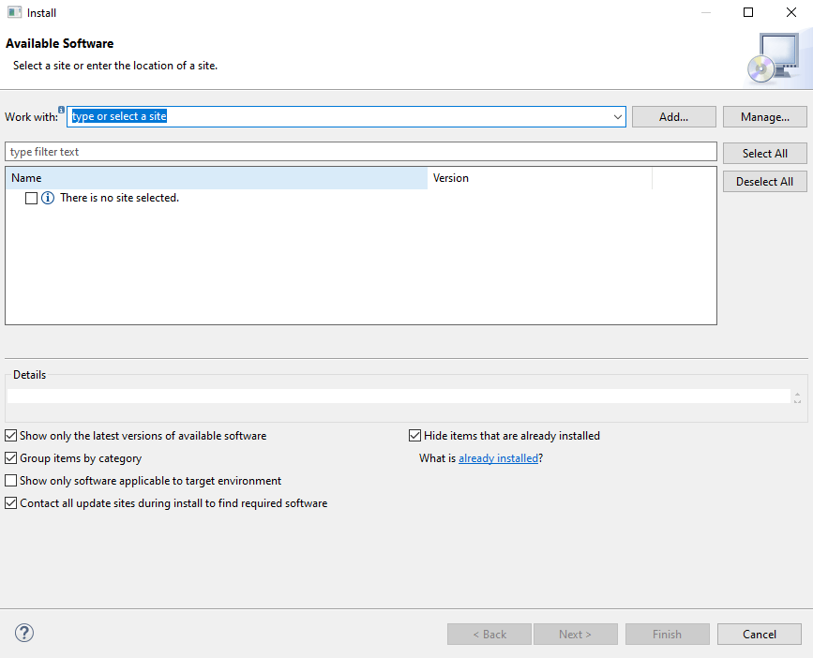Available Software

Then Click on Add button. After that, in the Name text box, enter EGit, and in the URL text box, enter **https://download.eclipse.org/egit/updates/**. Then Click Add in the dialog box.

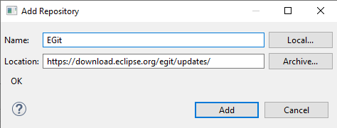Enter Details

Then It Will Display all the related extensions. There you need to select all the checkboxes and click next.

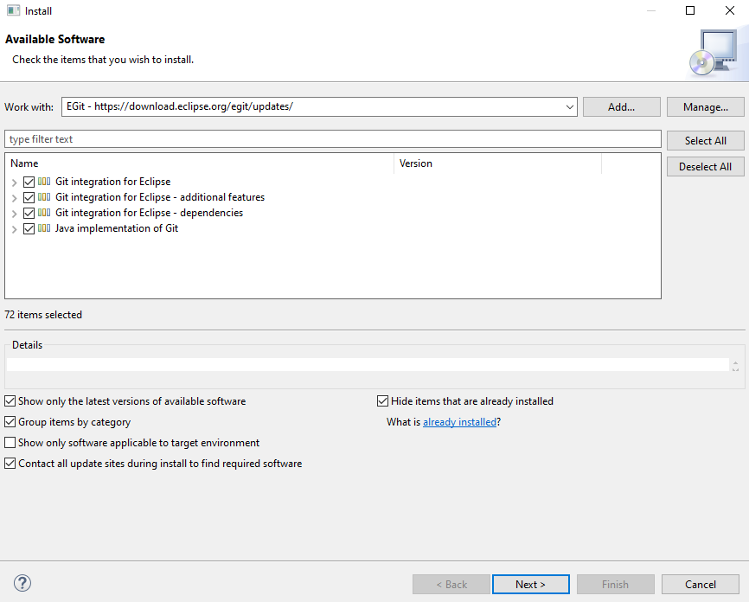Select All The Check Boxes

After that, accept the terms and conditions and Click finish. Once you click, finish the EGit install becomes successfully completed.

**Create GitHub Account:** During the GitHub blog post, we have already created a GitHub account. If you don’t have a GitHub account, then to create your GitHub account, you can follow our detailed blog post where we have described in detail **the**[**GitHub account create**](https://www.softwaretestingo.com/how-to-create-github-account/) process.

**Create a repo in your GitHub account**: After Creating an account on GitHub, Now you need to create a repository on GitHub. If you are worried about how to create a Git repository, then you can follow our detailed blog post on how to [**create GitHub Repository**](https://www.softwaretestingo.com/github-repository/).

**Clone/Fork an existing project from GitHub and import it into Eclipse**

**Import your repository into Eclipse**: the Final part is importing the repository to our GitHub account. So to Import your repository from GitHub, you can follow the below steps:

* Open Eclipse, with EGit, installed
* In Eclipse, choose File, then Import
* In the dialogue that opens, choose Git > Projects from Git and click Next

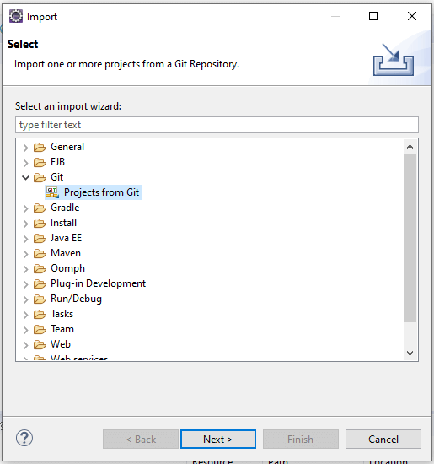Select Projects From Git

If You have an existing local repository on your local machine, then you can go with the existing local repository option. But for now, we are going to use the repository present on GitHub. So for that, you have to choose the Clone URI option.

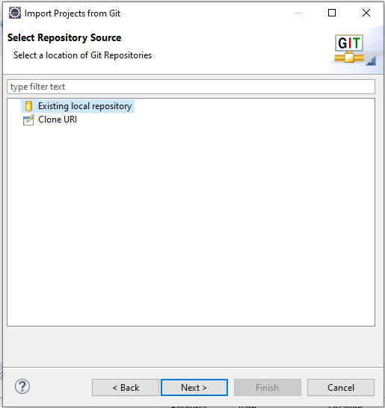Choose The Source Of the Repository

Click on Clone URI and click Next.

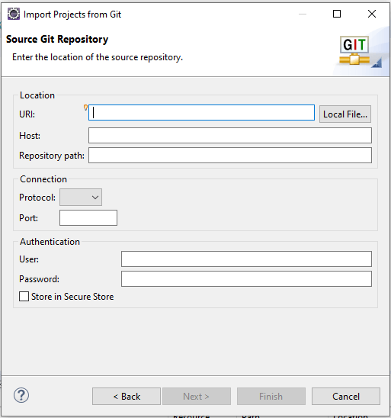Source git Repository Configuration

You have to fill in the required information such as URI, Host, Repository Path, Username, and password.

You can get the URI from your GitHub Repository URL.

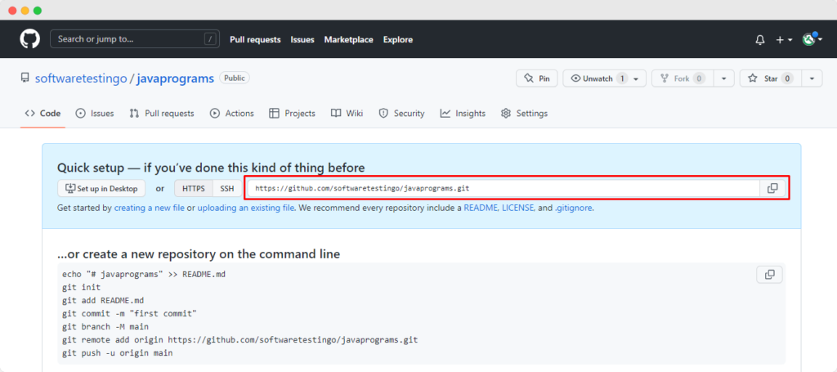You can Get URI Here.

You need to enter “**github.com**” in the Host text box because our repository is hosted on GitHub.com. and in the repository path, you need to enter the path of the repository.

The Full URL of our repository looks something like this “**https://github.com/softwaretestingo/javaprograms**” but we need to mention the username and the repository Name. In This case which is “/**softwaretestingo/javaprograms**“

Note: When you enter the URI, then automatically it will collect the information of HOST and repository URL:

After that, you have to enter your GitHub username and password for authentication and Select the Store in the secure store checkbox. Then Click Next.

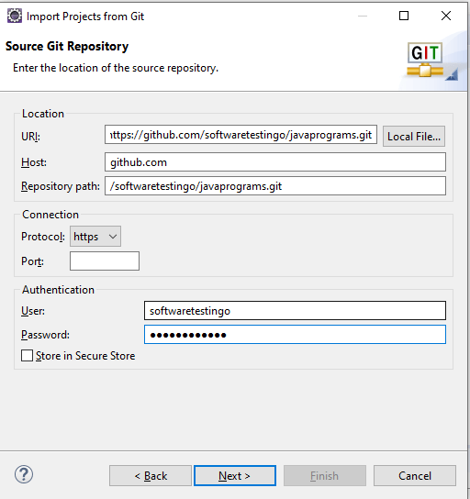The source git Repository Configuration With Values

After Clicking Next, it will connect with the GitHub Remote repository, and in Return, it will display all the branches of the mentioned repository. Currently, we have only one branch available, so the master branch is displaying.

Select the Branch and Click Next.

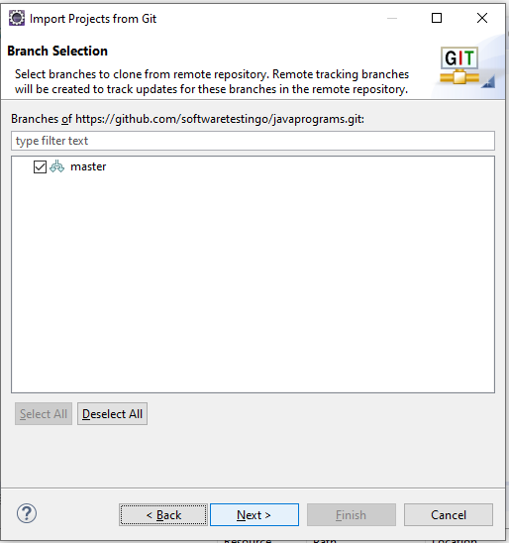Branch Selection

Here if you want to change the local repository location, then you can configure it here otherwise, if you want to proceed with the default location, then you can click next.

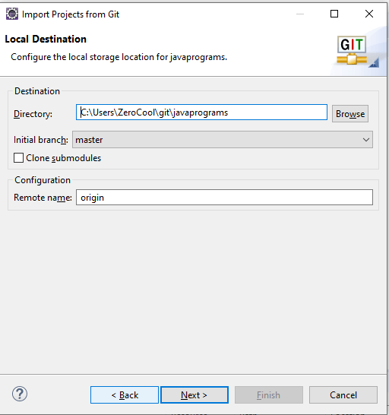Local Repository Destination Location

You can notice our remote is downloaded to our local machine. And you can click next.

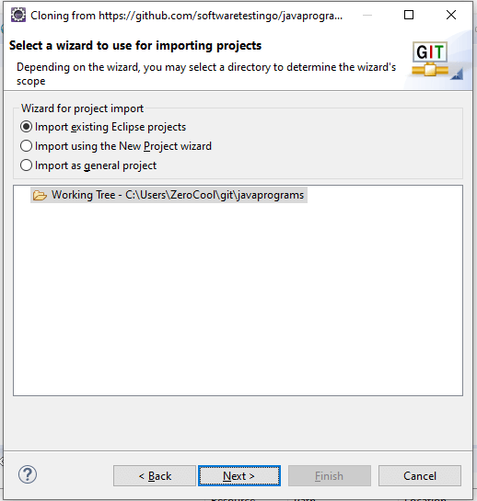Remote Repository is Downloaded

Currently, in our repository, we don’t have any projects. That’s why we are getting this screen. If you have any projects, then those projects will be listed here. We don’t have any projects here so I will create a project here. So select Import Using the New Project wizard and click the finish button.

**Note:**If any project is on your repository, you will not get the options below.

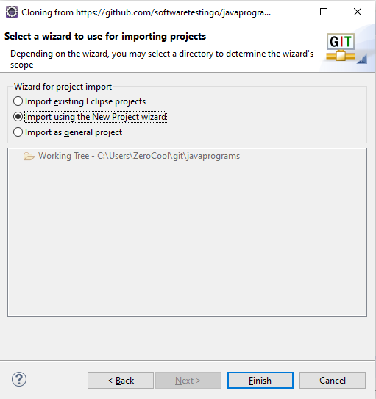New Project

Another new pop-up will appear on the Click Finish button, and we select Java Project. If you want to create any other type of project, you can select any other one.

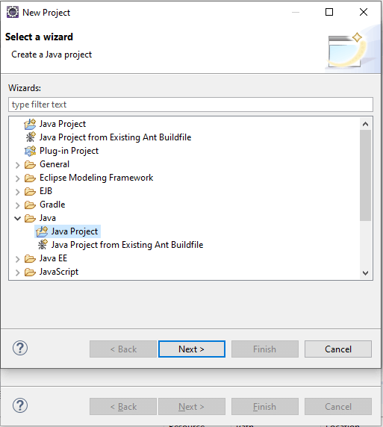Create Java Project

Select Java Project and click Next. On Click Next, it will ask for your Project Information.

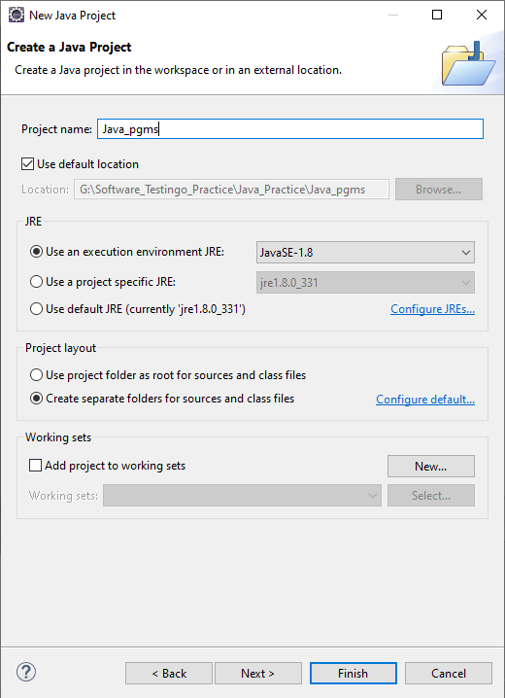Create A Java Project

Click Finish Button. And the Java Project is added to Eclipse.

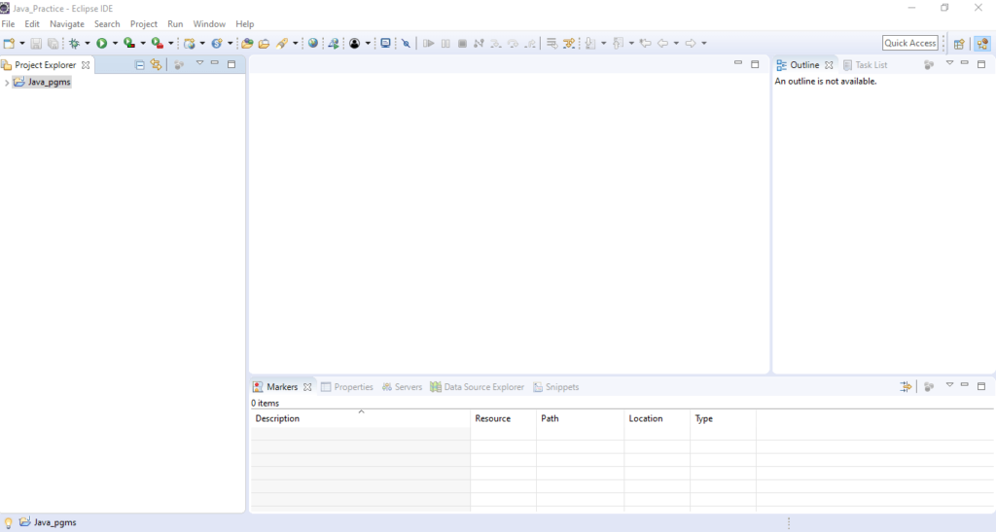Eclipse Java Project

**How to Push Changes of Existing Repository to Remote Repository?**

To Connect with Remote or Share your Project, you have to right-click over your project and Choose Team – > Share Project.

Now we need to select the repository from the repository dropdown, or you can click on create button to create a repository on the local machine.

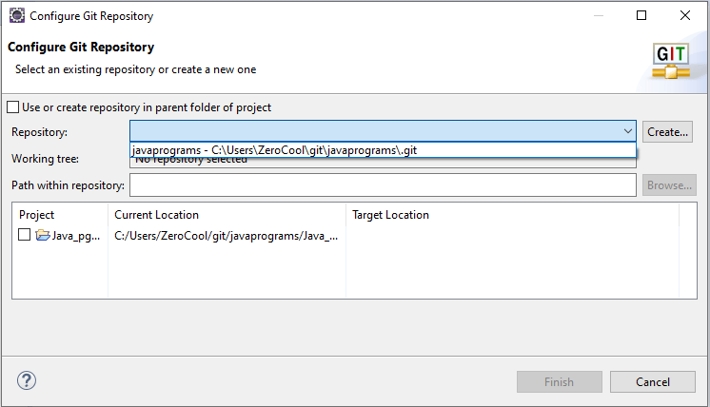Configure Git Repository

Select the Project Checkbox and Click the finish button.

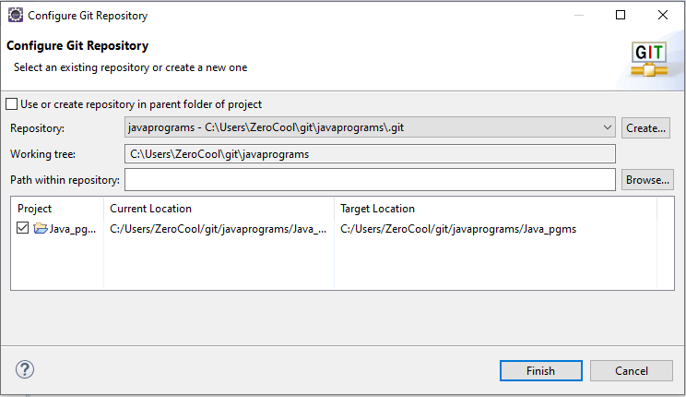Select the Project Checkbox Dropdown

After clicking the Finish button, you can notice that the Local project directory is linked with the remote repository.

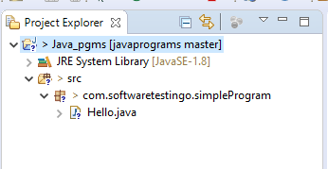Project Structure

We have added some files, and now, before pushing those changes to the remote repository, we need to commit those. So to commit, You have to follow the below steps.

**How to Push New Eclipse Project to GitHub**

To Push a repository to Github, we should have a project in our eclipse. So let us create a project. To Explain, I have created a simple Java project and in that, I have a class. Here is the structure

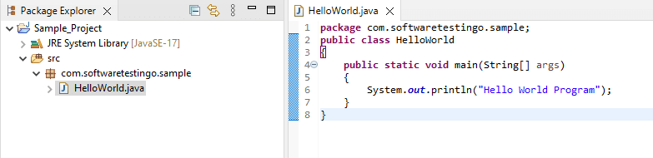

Now we are going to push this new Java project into our GitHub Account. For that, right-click on the project – Team – Share Project.

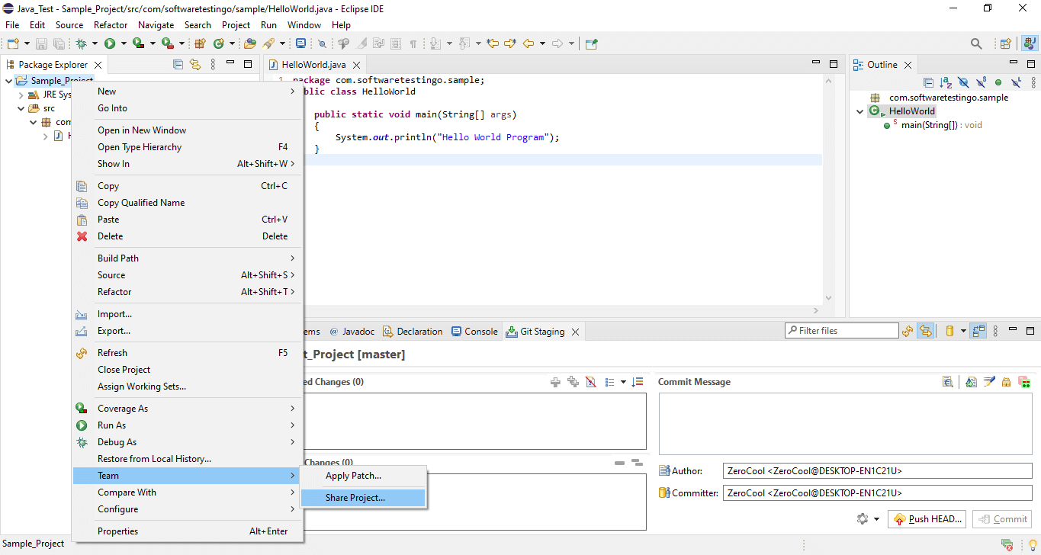

When you click on share project, you will get Configure Git Repository popup.

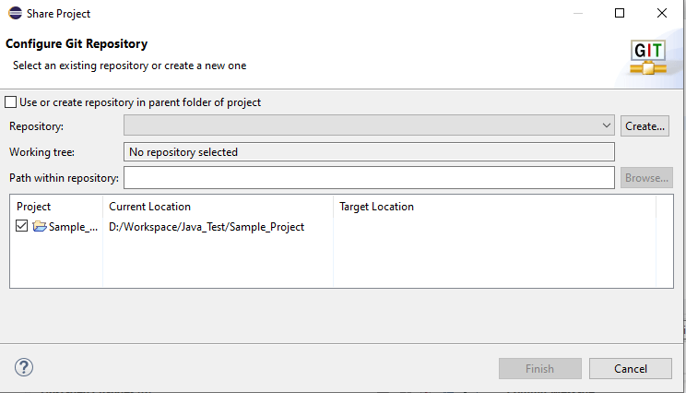

You can see the repository text box is blank, which means no repository is selected. We need to create a repository or need to select an existing repository.

In this scenario, as we don’t have any existing repository so we need to click on the create button. Then we will get another popup named Create a New Git Repository.

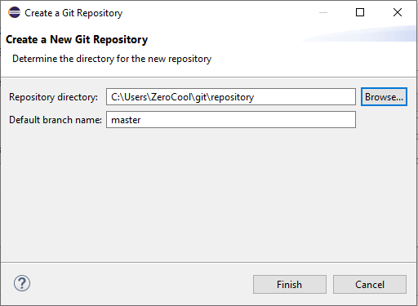

This popup is asking for the local repository directory and what is the default branch name.

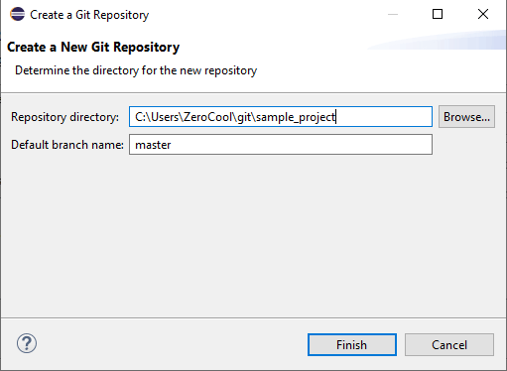

As you can see, I have set the local repository directory as “**C:\Users\ZeroCool\git\sample_project,**” and the default branch name is master, but you can give any name there and click finish.

After Clicking on you can notice in configure git repository popup the repository name and Target Location are updated, and click the finish button.

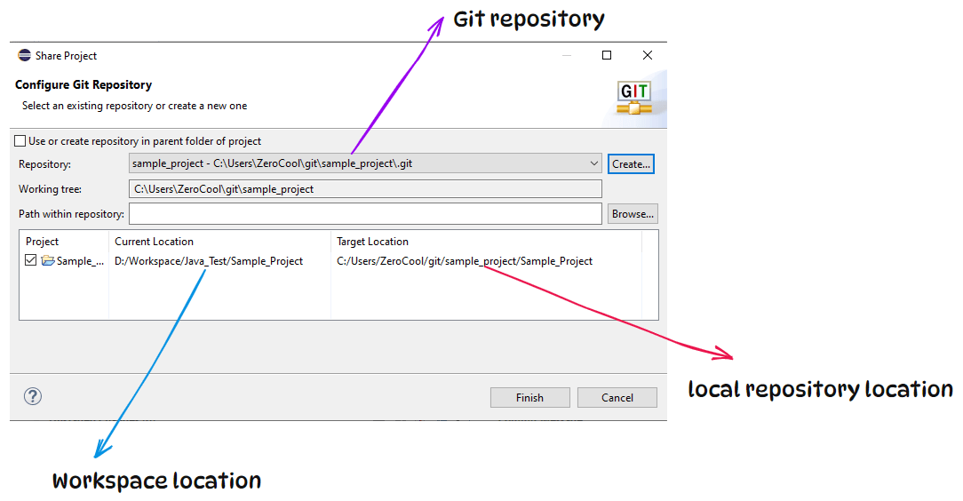

Now our local repository has been created, and if you notice the on your project file, packages, and project questions marks are displaying.

Up to this point, we are done with the setup of the local repository, but still, a few things are pending, like the remote repository (GitHub Repository) and the link between the Local and remote repository.

If you don’t have prior knowledge about [**How to create and GitHub account**](https://www.softwaretestingo.com/how-to-create-github-account/) and [**How to create a repository**](https://www.softwaretestingo.com/github-repository/), then you can follow the link and complete the action.

Once you are done with this, then we can proceed with linking Local and remote repositories by following the below steps:

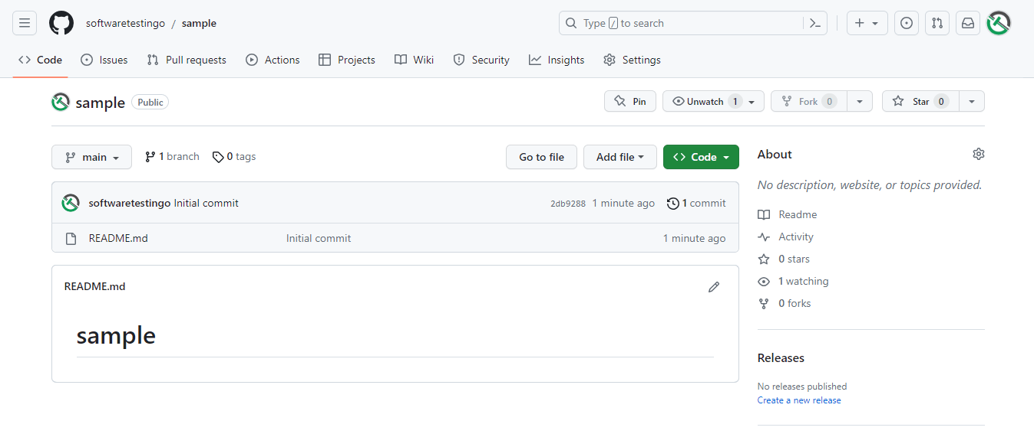

**To Connect to the Remote Repository**

Click on the code button and copy the HTTPS URL of the remote repository.

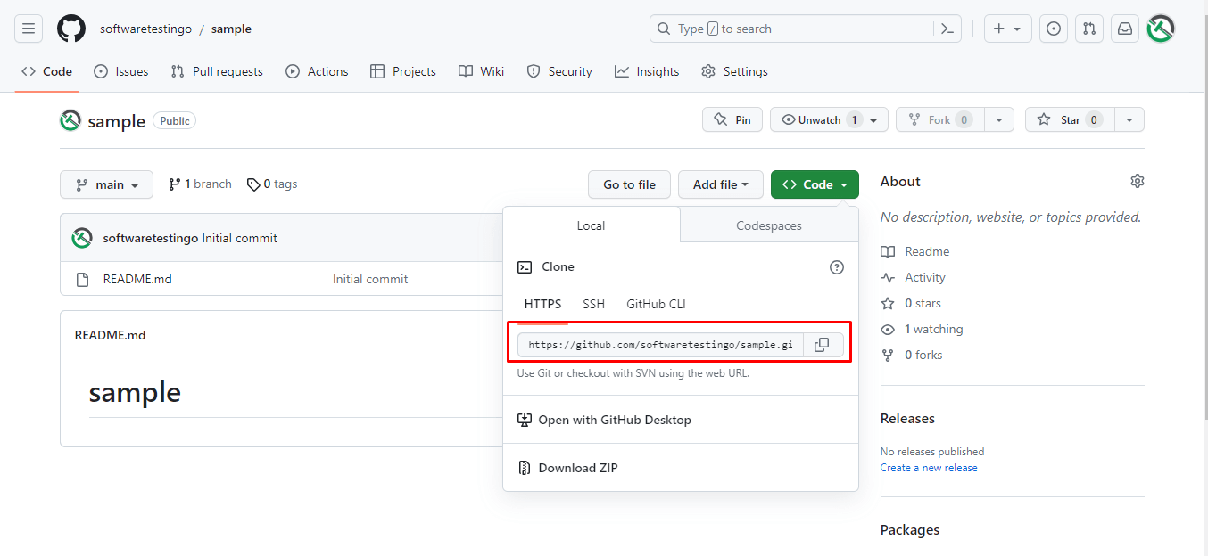

To Connect Eclipse with the Remote repository, Right Click on the project – Team – Pull

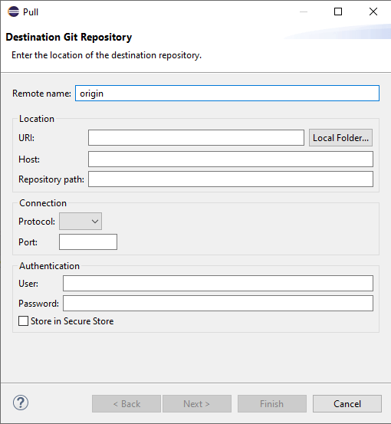

In the URI text box, paste the copied URL as you paste the URL, and when you paste the URL, automatically, the HOST, Repository Path, and protocol will be populated.

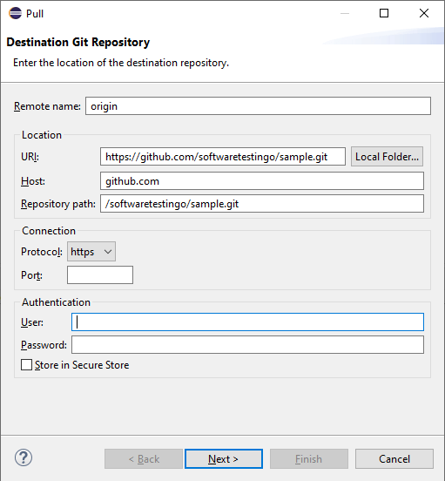

Then enter the username and password, then click next.

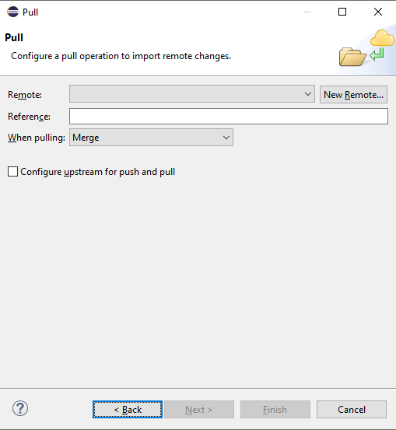

Click on the New Remote button and enter the same details in the same destination Git repository popup, and click finish. Now in the pull popup:

* Enter a reference name [refs/heads/main].
* Select Merge from the when pulling dropdown.
* Select the checkbox of configure upstream for push and pull

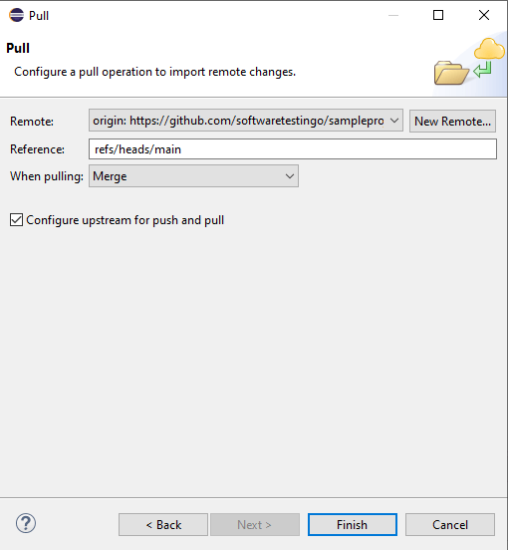

Now we have done with the link of the Local and remote repositories. The next thing is to commit the changes to the remote repository. To commit the changes, you can follow the below steps.

**How to Commit Files Using Eclipse?**

Right Click over the project — Team — Click on Commit

The Changes files will be displayed in the unstaged stanged area. You need to move those files from unstaged changes to the staged changes box, and after that, before performing the commit operation, you have to provide a meaningful commit message.

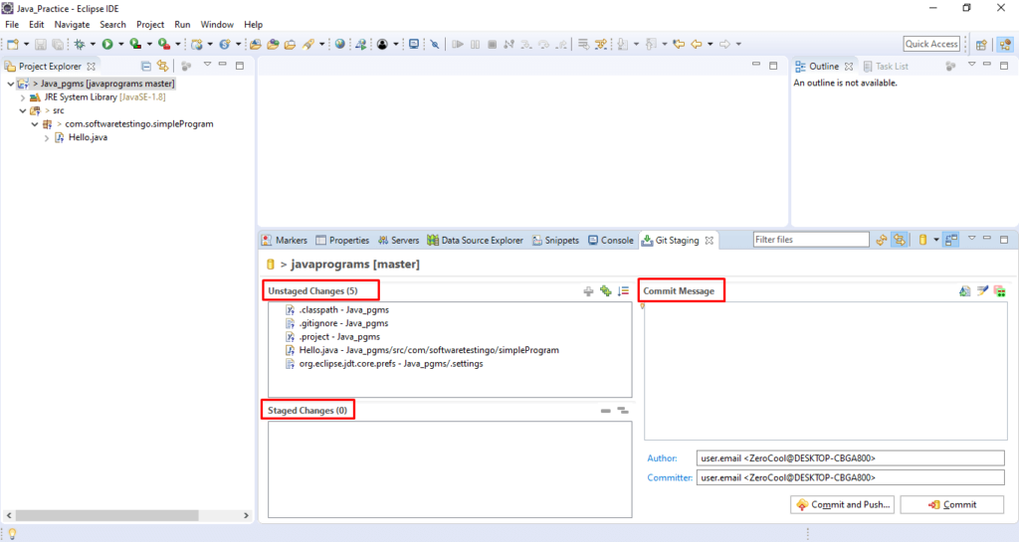How to Commit

After that, to commit the changes, you can click on the commit button, or you can click on the commit & push button to push the changes to the remote repository.

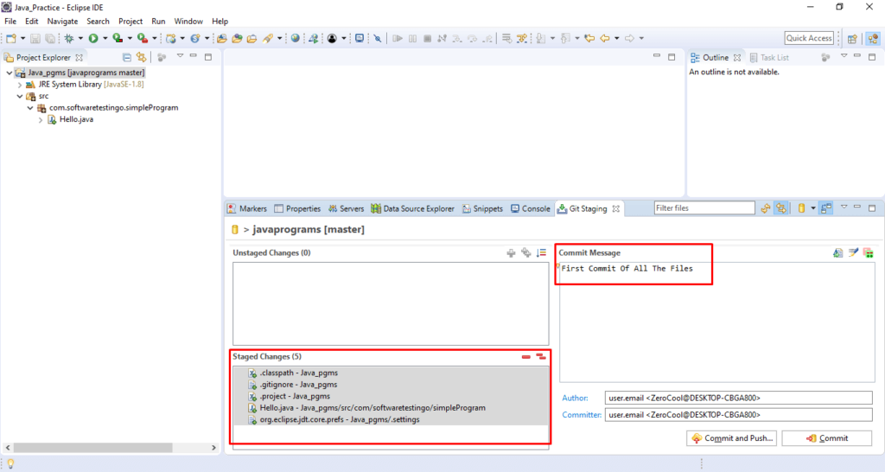Files Added Into Staged Area and Click Commit Button

Sometimes when you click on the Commit and Push button, then, you will get the login popup which will ask you for the username and password.

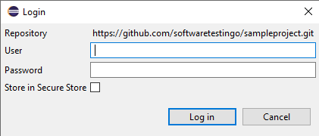

This is because GitHub has announced access tokens. To ignore this, you need to create access tokens. If you don’t know, then you can follow how to create personal access token post by clicking on the link.

Once you have the access token, you can enter the username and password and check the store in Secure store check and click on login.

Once the commit process completed you will get a popup like below:

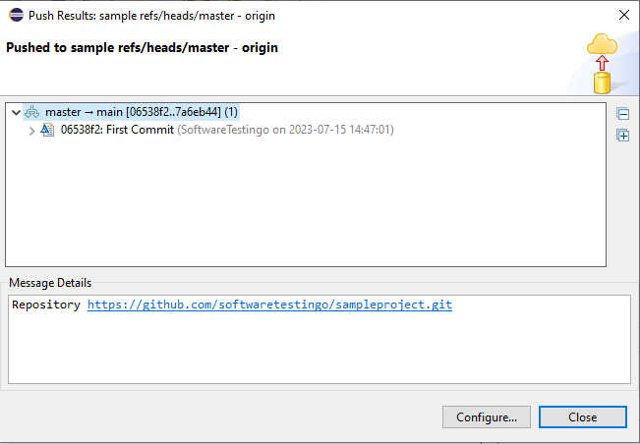

**Conclusion:**